### Web App For Startup Business

**Week 1: Azure Fundamentals & Setup**

**Students :**

1. **Ahmed Nasr Ahmed**
2. **Mohamed Mostafa**
3. **Abdulrahman Atef**
4. **Mahmoud Khaled**
5. **Ahmed Ali**
6. **Salah Ahmed**

Cloud Concepts and Azure Setup Report

# 1. Cloud Concepts Overview

## 1.1 What is Cloud Computing?

**Cloud computing** is the delivery of various services over the internet. These services include servers, storage, databases, networking, software, and more. The key characteristics of cloud computing are:

- **On-demand availability**: Resources are available as needed.

- **Scalability**: Resources can be scaled up or down based on demand.

- **Cost Efficiency**: Pay only for what you use, reducing capital expenditures on hardware.

- **Global Reach**: Cloud providers often have data centers worldwide, enabling global distribution.

## 1.2 Types of Cloud Models

- **Public Cloud**: Resources are provided by a third-party cloud service provider like Microsoft Azure, and are shared with other tenants.

- **Private Cloud**: Cloud infrastructure is used exclusively by one organization. It can be hosted on-site or by a third-party provider.

- **Hybrid Cloud**: Combines public and private clouds to allow data and applications to be shared between them, offering greater flexibility and optimization of existing infrastructure.

## 1.3 Service Models

- **Infrastructure as a Service (IaaS)**: Provides basic computing infrastructure (virtual machines, networking, storage). Azure Virtual Machines (VMs) is an example.

- **Platform as a Service (PaaS)**: Focuses on providing platforms to develop, run, and manage applications without the complexity of building and maintaining infrastructure. Azure App Services is an example.

- **Software as a Service (SaaS)**: Offers fully functional applications over the internet, like Microsoft 365.

## 1.4 Cloud Deployment Benefits

- **Cost Efficiency**: No upfront investment in physical hardware.

- **Flexibility and Mobility**: Access resources from any location with internet access.

- **Disaster Recovery**: Built-in redundancy and backup systems help ensure data safety.

- **Automatic Updates**: Cloud service providers handle infrastructure maintenance and security updates.

# 2. Azure Subscription Setup

## 2.1 What is an Azure Subscription?

An Azure subscription is a logical container used to provision and manage Azure resources. It allows organizations to segregate and control billing, policies, and access.

## 2.2 Steps to Create an Azure Subscription

1. **Sign up for an Azure account**:  
- Go to the Azure website.  
- Click on "Start Free" or "Try Azure for Free" if you’re a new user.  
- Sign in with a Microsoft account or create a new one.

2. **Choose a Subscription Plan:**  
- Pay-As-You-Go: Charges based on actual usage, which is ideal for variable workloads.  
- Enterprise Agreement: Suitable for large organizations with negotiated pricing.

3. **Billing Information:**  
- Provide payment information, even for free-tier users.  
- Azure will start billing according to the selected plan.

4. **Subscription Management:**  
- Once the subscription is created, access it through the Azure Portal.  
- View billing information, resource usage, and access controls under the Subscriptions tab in the portal.

## 2.3 Managing Subscriptions

- **Billing and Cost Management:** Monitor your expenses using Azure's Cost Management and Billing dashboard.

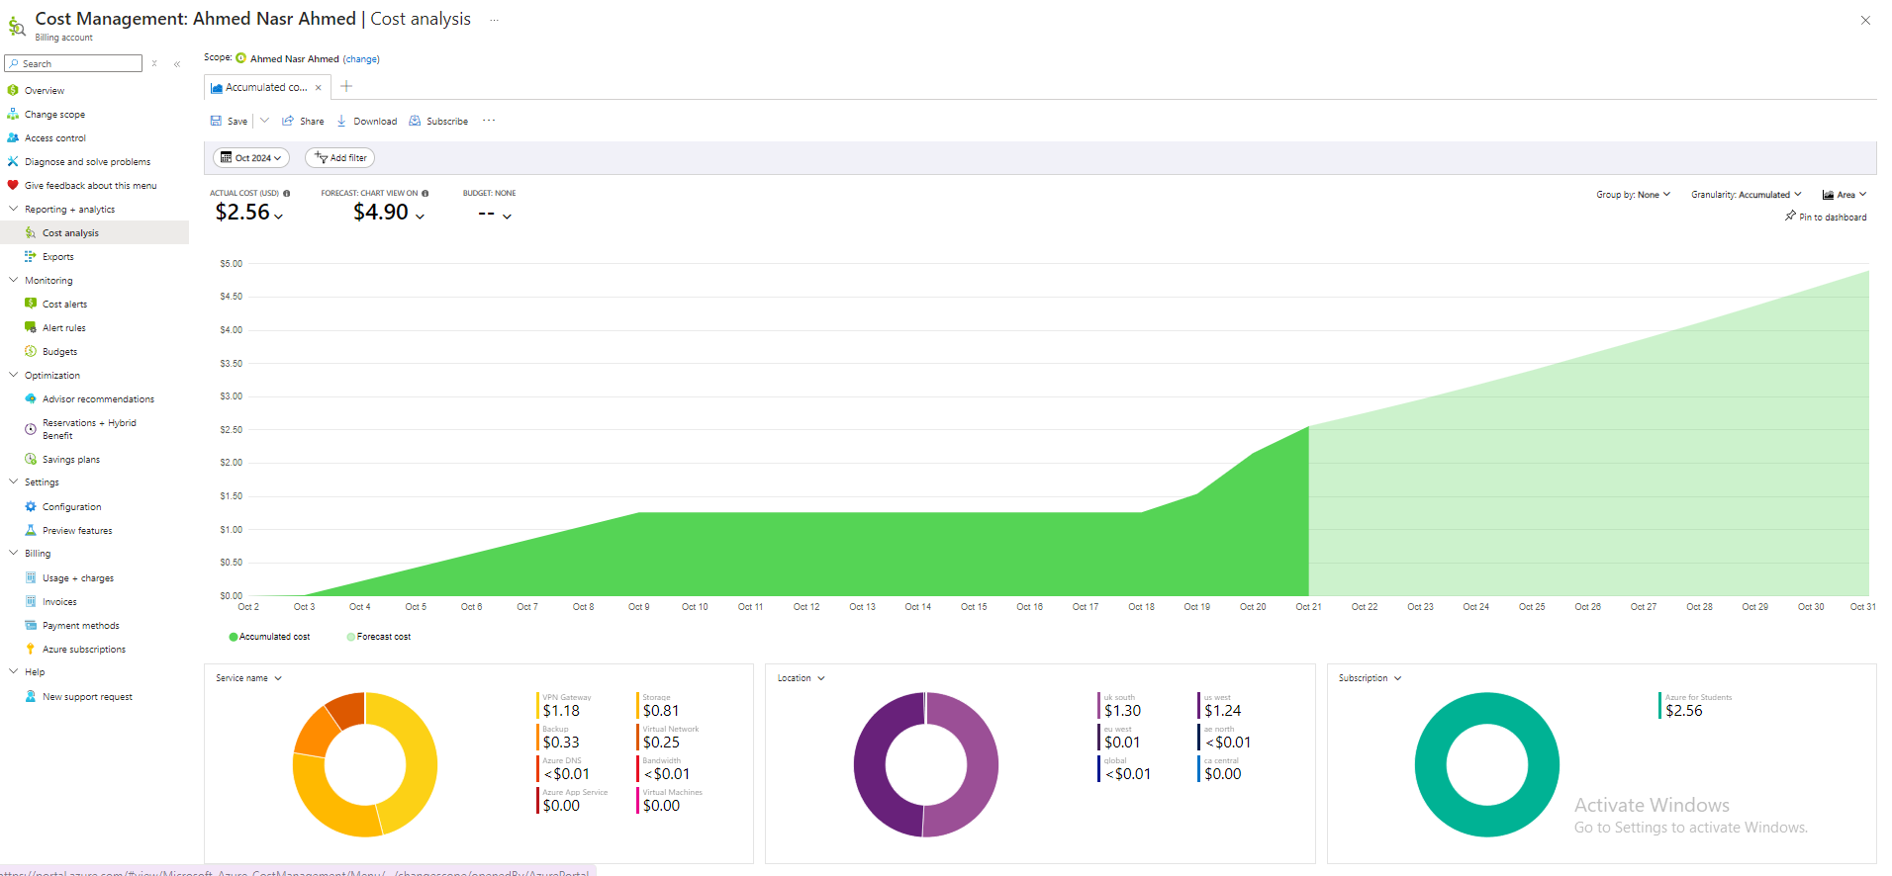

- Access Control: Use Azure’s Role-Based Access Control (RBAC) to assign users different access levels to resources in a subscription.

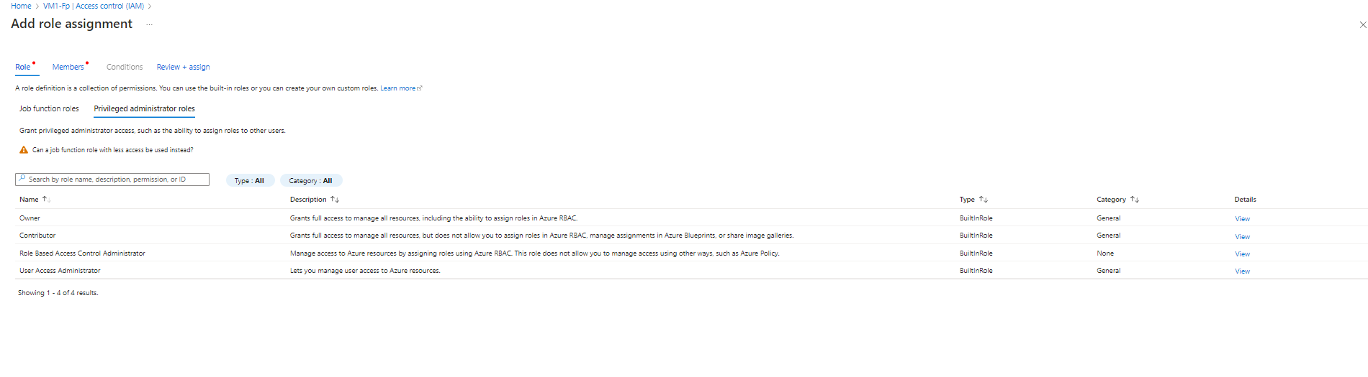

- **Resource Organization**: Use Resource Groups and Tags to manage and organize resources within the subscription.

# 3. Resource Group Setup

## 3.1 What is a Resource Group?

**A Resource Group** is a container that holds related resources for an Azure solution. It allows easy management and organization of Azure assets like virtual machines, storage accounts, and databases, all grouped logically for simplified administration.

## 3.2 Key Benefits of Resource Groups

- **Management Simplicity**: Resources can be deployed, managed, and monitored as a group.

- **Cost Tracking**: Cost management is easier as all the resources in a group can be monitored together.

- **Access Control**: Assign permissions to users at the resource group level for enhanced security.

- **Lifecycle Management**: Resources can be deployed and deleted together, making it easier to manage solutions from a lifecycle perspective.

## 3.3 Steps to Create a Resource Group

1. **Access Azure Portal:**  
- Go to the Azure Portal.

2. **Navigate to Resource Groups:**  
- In the search bar, type "Resource Groups" and click the result.

3. **Create a New Resource Group:**  
- Click on the "Create" button.

4. **Define Resource Group Settings:**  
- **Subscription**: Select the Azure subscription under which you want to create the group.  
- **Resource Group Name**: Provide a name that is easy to remember and associated with your project or resources.  
- **Region**: Choose the region closest to your target user base or operations.

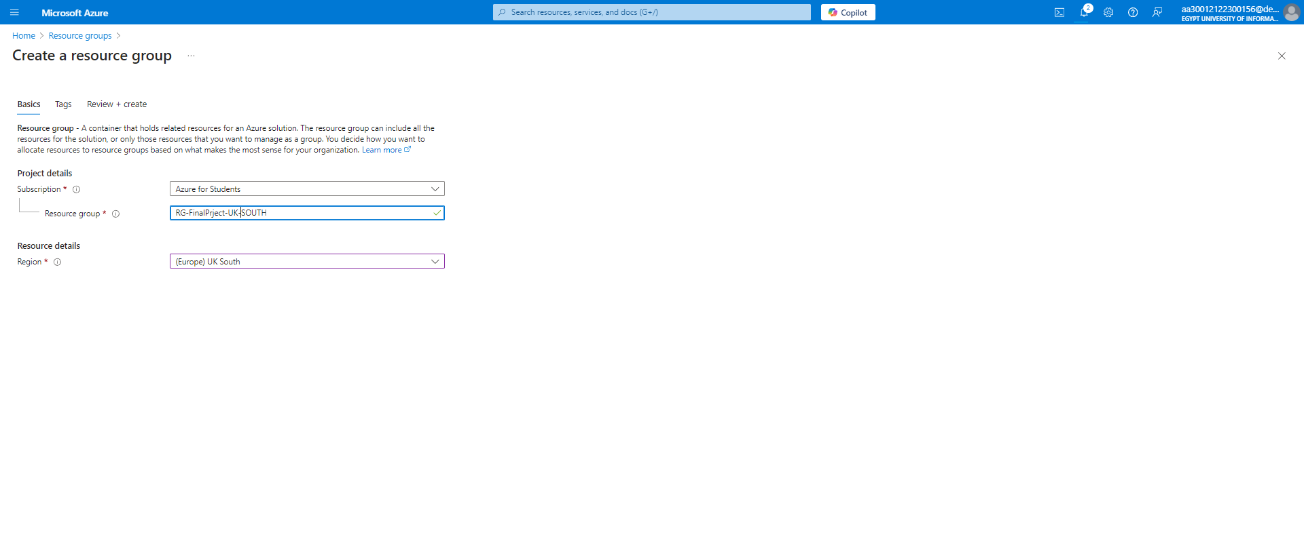

1. **Review and Create:**  
   - Once you've filled in the required fields, click "Review + Create." Verify the details, then click "Create."

## {66C0B897-5BA5-44B1-820E-CFC9AFEF49C4}

## 3.4 Organizing Resources within the Resource Group

Resources within a group should have the same lifecycle. For example, if you are deploying a web application, you might include the web server, database server, and network resources in one resource group. Use tags to assign metadata to Azure resources.

## 3.5 Managing Resource Groups

- Scaling Resources: Resources in a group can be scaled up or down as needed.

- Deleting Resources: Deleting a resource group will delete all resources within it. This is useful for managing the lifecycle of short-term projects or testing environments.

